**Lab – Report Testing**

December , 2015

This document is confidential and contains proprietary information, including trade secrets of CitiusTech. Neither the document nor any of the information contained in it may be reproduced or disclosed to any unauthorized person under any circumstances without the express written permission of CitiusTech.

**Document Control**

|  |  |
| --- | --- |
| Version | 1 |
| Created by | Dimple Manwani |
| Updated by |  |
| Reviewed by | Sugandha Agarwal |
| Date | 12th Oct 2015 |
| Earlier versions | NA |

**Table of Contents**

Prerequisites 3

Getting Started 3

Data Model 4

Restore Test DB – BIDataMart 5

Test Design 8

Member-wise Patient Satisfaction Report 8

Conclusion: 9

TO DO: 9

Overall Revenue Report 9

Year wise Revenue Growth 10

Disease-wise critical cases handled 11

Clinic-wise Patient Satisfaction Report 12

Clinic-wise Average Wait-Time 13

Year-wise revenue growth 14

Month-wise Incentives gained on Referrals 15

Patient Information with more than one Disease 15

Physician-wise Patient Information 16

Patient Visit Information 17

# Prerequisites

Participants undergoing this lab should be well-versed with the following,

* SQL Concepts
* Datawarehousing Concepts

# Getting Started

* **Overview**

This lab book describes how to perform testing of BI Reports in a DWH environment.

* **Software Requirement**

Should have access to Microsoft SQL Server.

* **Business Requirement**

LifeCare BI Portal has reports tab which displays various reports based on authorization rights.

This document covers detailed description for each of the reports which are generated from the BIDatamart.

# Data Model

Given below is the data model of ‘BIDataMart’ for your reference,



# Restore Test DB – BIDataMart

Copy the backup file Test_BIDatamart.bak on your local machine.

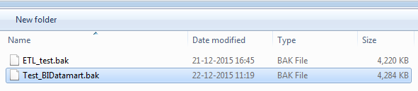

Open SQL Server Management Studio from Start Menu.

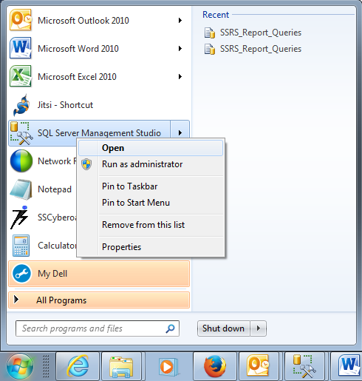

Connect to the DB Engine, using SQL Server Authentication

User- sa

Password- password_123

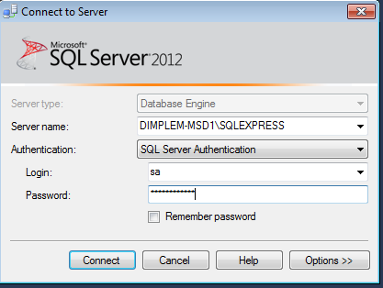

Right-Click on the Databases folder -> Restore Database

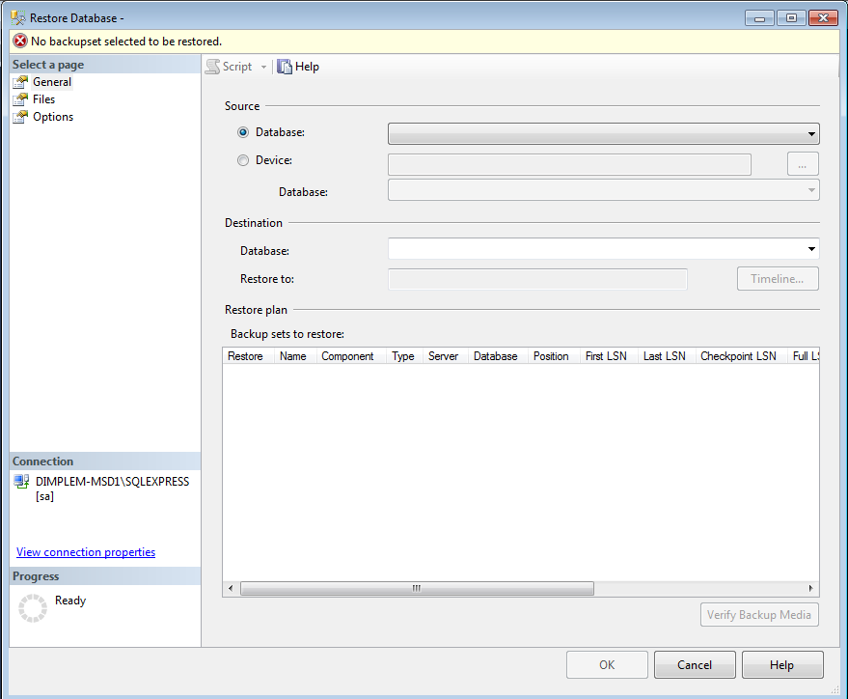

Select Device -> Browse & Add the backup file ‘Test_BIDatamart.bak’

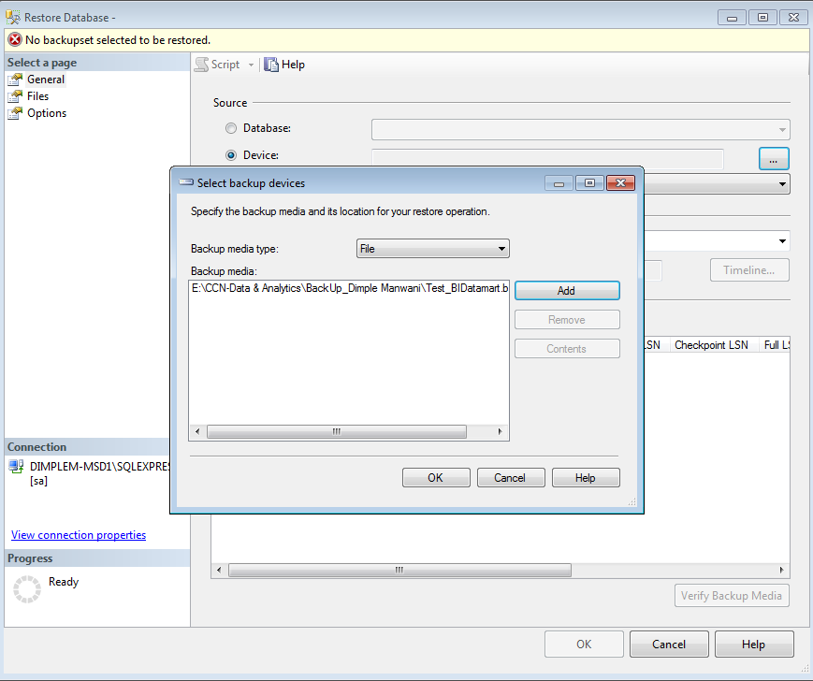 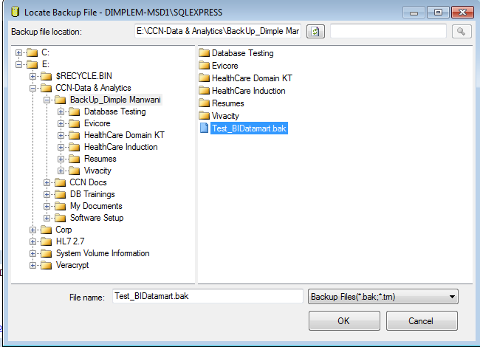

Verify the backup file name appears under Restore plan tab.

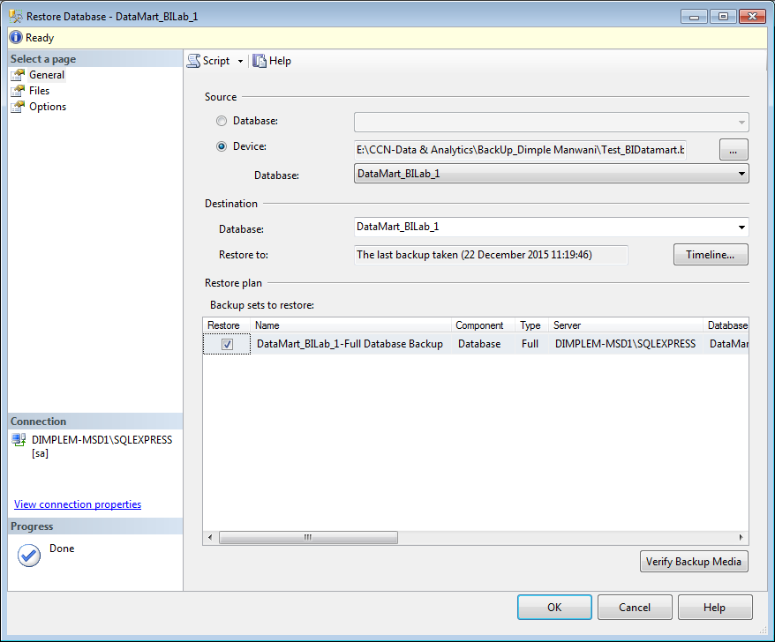

Go to the Options tab,

Check **‘Overwrite the existing database’**

Uncheck **‘Take tail-log backup before restore’**. Click OK.

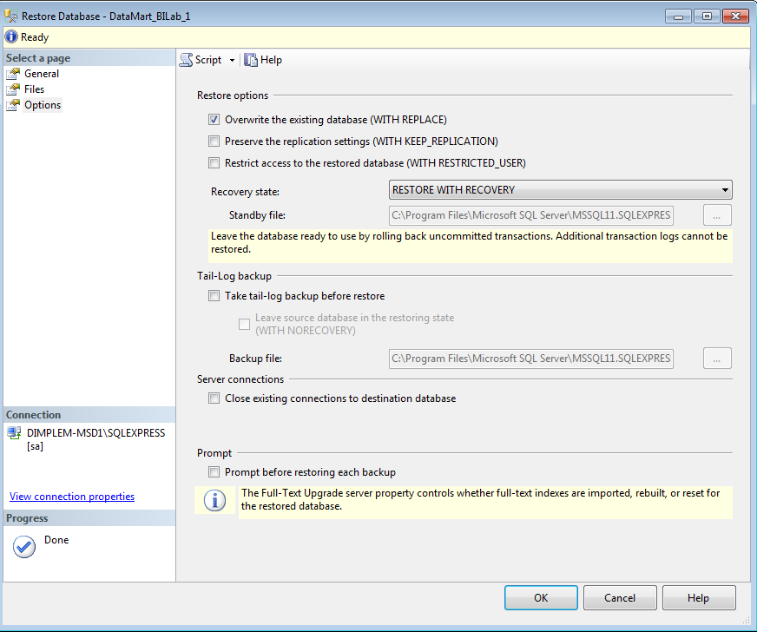

Check Test DB is now restored-

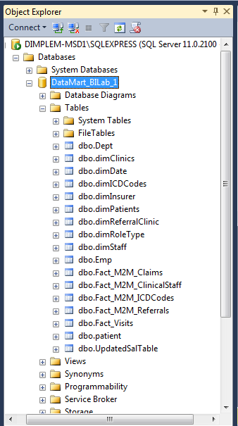

# Test Design

Now, lets understand each of the Reporting requirements mentioned below to design test scenarios & test cases for them,

## Member-wise Patient Satisfaction Report

### Report Description

Patient gives satisfaction feedback after every visit. This report shows patient satisfaction in terms of percentage for all physicians\head physicians.

### Filters Applicable

1. Role Type: report has role type filter. Selecting the value e.g. Physician\Head Physician will display corresponding records according to role type.

### Sample Report Screen

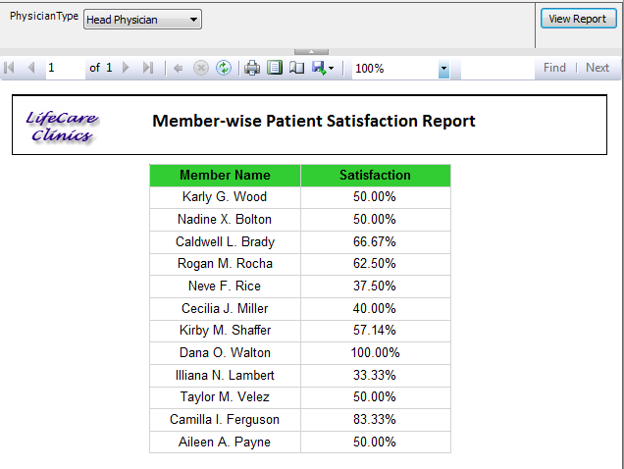

Refer attachment for test cases for the above report,



# Test Execution

Let us execute the test cases for Member-wise Patient Satisfaction Report and capture the test evidence.

Note that we are using SSRS as an ETL tool and SQL Server as a DWH environment for this training purpose.

## Report Deployment

Follow the steps given below to deploy the SSRS reports in your environment for test execution,

1. Click on the URL placed on the shared path to render the SSRS report
2. Login into the Database server 10.30.5.138 with SQL authentication and credentials as,

Username- sa

Password- password_123

1. Execute the report test cases mentioned in the document above.

## Conclusion:

Report Testing includes-

* Verify data displayed on the reports is as per business requirements.
* Make sure the front-end UI Objects are present & functioning as expected.
* Validate the report are generated within the prescribed time frames which confirms the performance criteria.

# TO DO:

Create & Execute TestScenarios and TestCases for each of the below requirements,

## Overall Revenue Report

### Report Description

This report shows year-wise revenue growth for all clinics.

### Filters Applicable

None

### Sample Report Screen

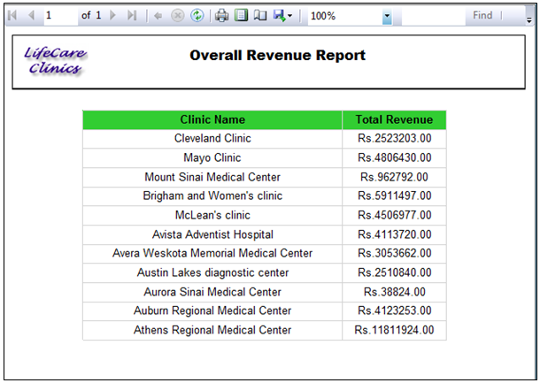

## Year wise Revenue Growth

### Report Description

This report shows year-wise revenue generated by each clinic

### Filters Applicable

1. Year : selecting particular year will display the revenues generated in that year for each clinic

### Sample Report Screen

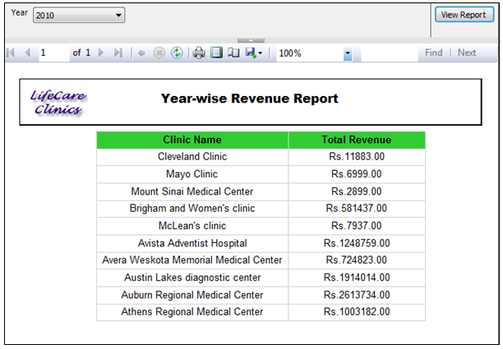

## Disease-wise critical cases handled

### Report Description

This report shows disease-wise critical cases handled by each Head physicians per clinic

### Filters Applicable

1. Clinic Name: Selecting particular clinic will display the Diagnosis names. Drilling down in each category will display the corresponding physician’s names who have handled cases in the same category.

### Sample Report Screen

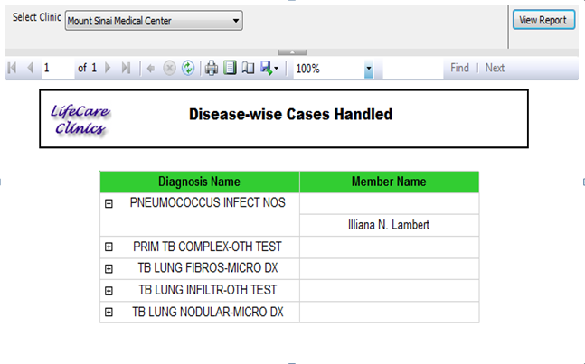

## Clinic-wise Patient Satisfaction Report

### Report Description

Patient gives satisfaction feedback after every visit. This report shows clinic-wise patient satisfaction report for all members working under particular clinic.

### Filters Applicable

None

### Sample Report Screen

Initially report displays all clinic names.

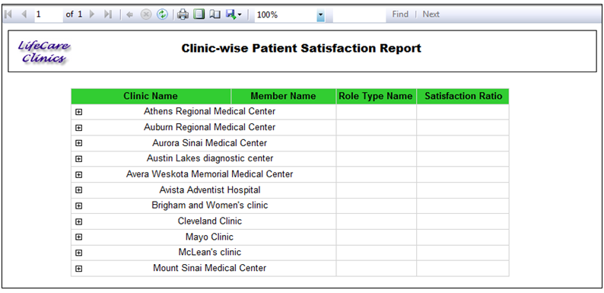

Drilling down one level will display all members working under that clinic.

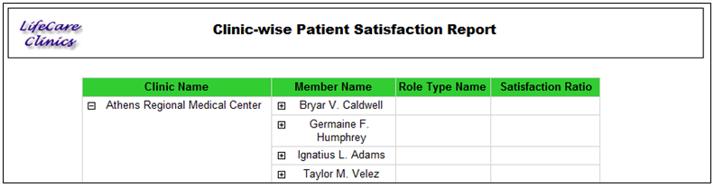

Drilling down one level will display the role type & satisfaction in terms of percentage.

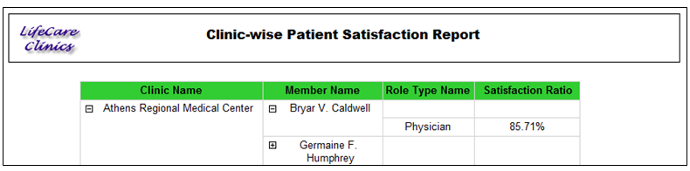

## Clinic-wise Average Wait-Time

### Report Description

System records arrived time, check-in & check-out time per visit. This report shows average wait time of patients for each clinic in terms of mins.

### Filters Applicable

None

### Sample Report Screen

## Year-wise revenue growth

### Report Description

This report shows year-wise revenue total growth.

### Filters Applicable

None

Sample Report Screen

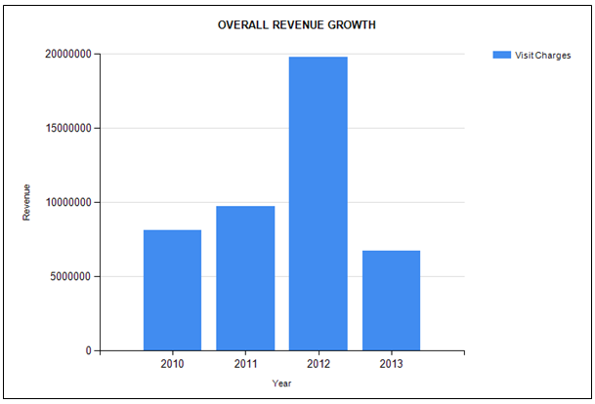

## Month-wise Incentives gained on Referrals

### Report Description

This report shows month-wise incentives gained on referrals.

Filters Applicable

1. Year\Month: Selecting year will allow you to select month. Member names & incentives gained will be displayed accordingly.

Sample Report Screen

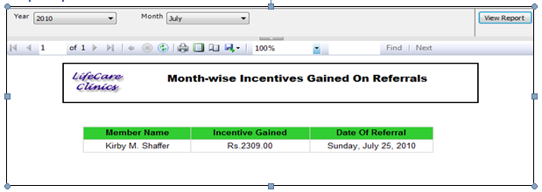

## Patient Information with more than one Disease

### Report Description

This report shows details of patients diagnosed with more than one disease.

Filters Applicable

None

Sample Report Screen

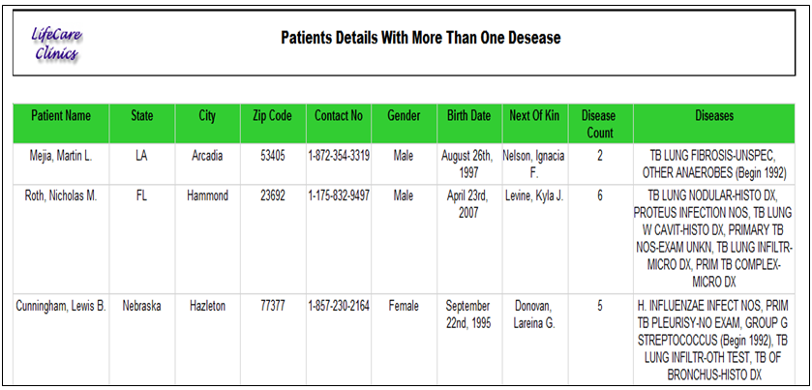

## Physician-wise Patient Information

### Report Description

This reports shows details of patient handled by particular physician

Filters Applicable

Staff Name (Physician name): selecting the physician name will display the details of the patients handled by him\her.

Sample Report Screen

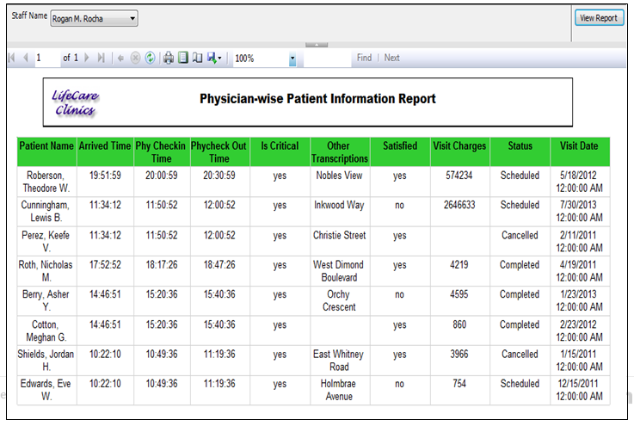

## Patient Visit Information

### Report Description

This reports shows details of patient like address, visit information & disease diagnosed

Filters Applicable

Patient Name (Patient name): selecting the patient name will display the details of the patients.

Sample Report Screen

